Should be made in groups of max 6 students, handwritten, submitted on the next F2F session. Tardiness will cause a penalty of -5 per day. Distribute the homework within your group. Example: Ali will do number 1, Badu will do number 2, Charlie will do number 3, etc., and then staple your work together. Put your names and your sequential number on the first page. Do not put in my locker, it will be neglected.

1. a. Find dy/dx of y = 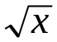 using limit.
b. Find dy/dx of y = 3x²+4x using limit
2. Find dy/dx from x³ + y³ – 2x²y² – 4x³y² +4=0
3. Find the equation of tangent line and normal line to y = e^{2x} at x=1.
4. Find the derivative (dy/dx) of the following functions.
a. 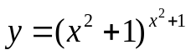 b.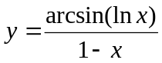
5. The normal line to the curve 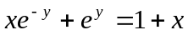 at the point 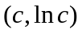has a y–intercept 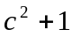. Determine exact the value of c.
6. Find first the derivative of:
- 